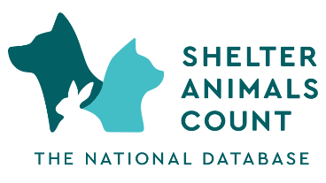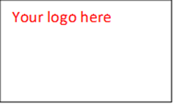

Your contact name, cell number, email

“Designer Dogs” like Doodles Have Popularized Mixed-Breeds. Now People Can
Help by Adopting Rather Than Buying Them. National Mutt Day is December 2
More than 60% of Shelters and Rescues Surveyed Say They’re Getting Doodles, Other Hybrids
(Local details if you are seeing this trend in your organization/community as well)
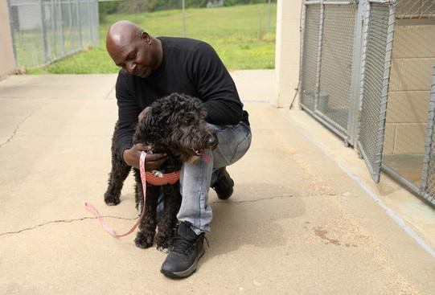
Photo Credit: Heartspeak

Assets: Photos (A few adoptable "designer dogs" from AdoptaPet)

CITY, Nov. XX, 2023 – Shelter Animals Count (SAC), the most trusted and current source for animal sheltering data, recently surveyed shelters and rescues to get a snapshot of what kinds of dogs are coming through their doors. With 314 responses from organizations across 45 states, more than 60% of respondents said they’re receiving doodles and other intentional mixed breeds. Ahead of National Mutt Day, Dec. 2, this is the perfect time to appreciate the wonderful characteristics of mixed-breed dogs and focus on embracing, saving and celebrating them, and raising awareness of their availability in shelters across the country.

What many people don’t know—and may not believe—is that more and more hybrid dogs and puppies like doodles, oodles, and poos, as well as dozens of other non-poodle combinations, are arriving at shelters for the same reasons that other dogs do, so many of the mixed breeds in shelters and rescues these days are not even of the accidental variety.
Local info. Optional quote from director or spokesperson about your organization/local situation with designer dogs.
Now that people’s minds have been opened to the alluring world of mixes, animal advocates encourage an attitude shift to get people to stop buying so-called "designer dogs" and start adopting them from shelters and rescues who are desperate for adopters. Due to the increasing trend of home breeding as a side hustle, and the ongoing issue of puppy mills, many shelters are not only receiving people’s pups they purchased and can’t keep, but also leftover puppies that breeders can’t sell, and adult breeder dogs that are no longer wanted or needed.

Other key findings from SAC’s survey:
- Nearly 90% of survey respondents said they’re receiving puppies from their communities.
- More than half (54%) said they’re getting "leftover" puppies/litters from breeders who can't sell them.
- Nearly 60% said they’re receiving surrenders (or surrender requests) of dogs that people say they paid a lot of money for and now can't afford to keep.

One survey respondent said, “We are getting many doodles from the local pet store. People buy them, keep them for about six months, and then surrender them.” Another said, “We have almost as many purebred or so-called designer hybrids as we do ‘regular’ mixed breeds come into our shelter each month. If you look, you can find almost anything in a shelter.”

Thanks to the popularity and proliferation of mixes with names that sound like they were dreamed up by Dr. Seuss, potential adopters have a wide variety of magnificent mixes to choose from. Here are 45 of the breed-types received recently by the shelter survey participants:
Goldendoodle, Labradoodle, Bernedoodle, Aussiedoodle, Sheepadoodle, Shepadoodle, Huskydoodle, Pitdoodle, Rottiedoodle, St. Berdoodle, Houndoodle, Schnoodle, Cavapoo, Havapoo, Cockapoo, Shipoo, Chipoo, Maltipoo, Terripoo, Corgipoo, Eskipoo, Yorkipoo, Sammypoo, Pitsky, Shepsky, Pomsky, Chug, Puggle, Chiweenie, Shichon, Frug, Frenchton, Malshi, French Bully, Bully Tzu, Goldendale, Goldenbull, Goldenheeler, Aussiedor, King Schnauzer, Morkie, Chorkie, Shorkie, Shih Apso, Beltie and Beabull.

Shifting from buying puppies to adopting homeless pets has become increasingly critical, as the recent Shelter Animals Count report highlights that animal shelters across the country are in crisis. Nationally, shelters are in their third year of having too many animals and not enough adoptions — especially for dogs. The current trend shows dog adoptions down 1.2% from 2022, after shelters saw a 2.5% increase in dogs arriving January-September 2023. Download SAC’s full Q3 report PDF here.

People can celebrate Mutt Day any day, by visiting (your organization) –or starting on their websites– or by checking pet adoption databases like AdoptaPet.com.

“While designer dogs often have amusing 'breed' names, they are technically still (what we lovingly call) 'mutts' - and Mutt Day is a great way to celebrate the mixed-breed dogs in our lives, or to expand your family by adopting a mutt from your local animal shelter for an affordable price.” said Stephanie Filer, Executive Director of Shelter Animals Count.

“Whether your adopted dream dog was intentionally bred or an accident, you can use some of the money you save with affordable adoption fees to purchase a DNA test, like Wisdom Panel, to learn what’s in the recipe, and make up your own trendy breed name. You can invent one or google it, because chances are, someone has already named that mix,” Filer added.

“No one will ask you if your dog was bred on purpose,” she explained. “And every time you say, ‘I adopted him from a shelter,’ you open people’s minds to the amazing dogs waiting for adoption. You can be part of the solution many times over!”

Animal organizations across the country continue to struggle with over-capacity status and urgently need community support, expressing a dire need for members of their communities to adopt or foster from local shelters or rescue organizations, spay or neuter their pets, and volunteer or donate.

About Shelter Animals Count (SAC): SAC is a collaborative, industry-led nonprofit organization formed by a diverse group of animal welfare agencies to create and share The National Database of sheltered animal statistics, providing facts and enabling insights that will improve animal welfare throughout the country.
www.shelteranimalscount.org
@shelteranimalscount @Shelter Animals Count
Your organization’s ‘About’ info here:

